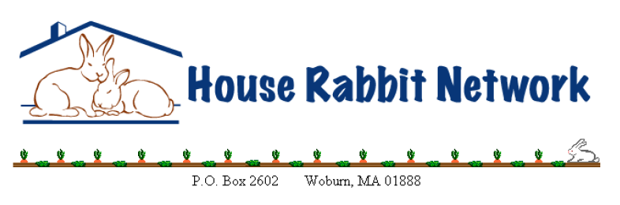
I, _____________________________________________, (“rabbit parent”)
the legal owner of ______________________________________,
am leaving my rabbit(s) for boarding with
(boarding home) ______________________________________
from (start date) __________________ to (end date) __________________.
Rabbit Information
Rabbit Name:
Rabbit Gender:
Feeding Instructions:
Please describe any behavioral problems, dietary conditions, or other important information for the boarding home:
Medication Instructions:
My rabbit(s) have the following preexisting medical conditions: _________________________

Veterinarian Clinic:
Clinic Phone:

Rabbit Boarding Agreement
This Rabbit Boarding Agreement (“Agreement”) is made and entered into between the House Rabbit Network (“HRN”), a 501(c)(3) non-profit, and the rabbit parent, identified above. HRN provides rabbit boarding services through its volunteers. I, as the rabbit parent, hereby engage HRN to provide boarding services for my rabbit(s) as set forth by this Agreement.
Payment Standard Rates/day Peak Season/day
Single $15.00 $17.00
Bonded Pair $19.00 $22.00
Bonded Trio $22.00 $25.00
**Peak season rates are in effect June through August, Thanksgiving to New Year’s Day, and all major holidays.

If you have multiple rabbits that are NOT bonded, the cost per day would be the single rate times the number of rabbits.

The rate for boarding is to be paid in full when the rabbit(s) are dropped off for boarding. Make checks payable to House Rabbit Network. I understand this is a donation to House Rabbit Network. HRN recommends that you provide the same pellets that your rabbit(s) are used to at home for consistency. Each sitter may have specific requests for items for you to provide for your bun(s), discuss this with the sitter when you contact each other. The boarding rate does not cover any medical costs that may arise. I have fully disclosed any preexisting conditions or afflictions of which I have knowledge.
Medical Treatment
In the event that the boarding home decides medical care is necessary, I do hereby give permission for the boarding home to provide any medical care that the boarding home, in its sole discretion, determines is reasonably needed for my pet for any condition which may develop or be discovered while my pet is boarding, or any preexisting condition disclosed above. I understand that every reasonable effort will be made to contact me prior to performing any tests or treatments on my pet, but I agree that failure to reach me shall not result in a postponement of such tests or treatments if such postponement could be harmful to my rabbit(s), or if my rabbit(s) are suffering. While every effort will be made to save my pet, I understand that the boarding home may euthanize my pet if it is the humane thing to do. I agree to pay in full for any such care given to my pet as described above, including but not limited to, veterinary fees, veterinary tests and treatments, and any prescriptions.

Liability
I agree to release, indemnify, and hold harmless HRN and the foster home from any and all manner of damages, claims, loss, liabilities, costs or expenses, including reasonable attorney’s fees and related costs, arising out of or related to HRN’s services, except which may arise from the gross negligence or intentional and willful misconduct of HRN or the foster home, including, without limitation, (i) any inaccuracy in any statement I made or information I provided to HRN; (ii) my rabbit, including but not limited to destruction of property, bites or scratches, injury, and transmission of disease, and (iii) any action by me which is in breach of the terms and conditions of this agreement.
I expressly agree that the maximum aggregate liability of HRN and its officers, directors, employees, contractors, volunteers, and representatives (the “HRN Parties”) shall be limited to the lesser of the current chattel value of a pet rabbit or the sum of $75.00.
Pick-Up and Cancellation
If I need to cancel my Boarding reservation, I will contact HRN as soon as possible, but in any event, no later than 2 days prior to the Boarding start date. I understand that HRN reserves the right to charge a late cancellation fee after this time. I agree to promptly pick up my rabbit(s) upon the end date listed above. If, for some reason, I am unable to pick up my rabbit(s) on the date listed above I will contact HRN as soon as possible to make arrangements to extend my rabbit’s stay and I will pay the additional charges based upon the aforesaid daily rate. I understand that if my rabbit(s) are not picked up within one week of the end date, they will be turned over to a shelter.

I have read this entire Agreement, I have discussed any questions I have regarding this Agreement with HRN, and I agree to its terms.
Signature: _______________________
Date: ___________________________
Address: _____________________________________________________________________
_____________________________________________________________________________
While my pet is boarding, I can be reached by telephone at: ____________________________
Or email at _______________________________________________
Or contact __________________________ (friend/relative) at ___________________________
We urge you to check your email, voicemail, or answering machine routinely while out of town. If we are unable to reach you at the number you provided above, we will leave a message on your voicemail.

